**Long Transmission Line**



**Javier Jesús Macossay-Hernández**

**EE443 – Introduction to Power Systems**

**University of Southern California**

**Professor Robert Castro**

**Objective**

In power engineering, different transmission lines models are used to do system analysis. Depending on the length of the transmission line is the model used for it. Short model is from 0 miles to 50 miles, Medium or pie model ranges from 50 miles to 150 miles, and long model is larger than 150 miles.

**Introduction**

Through PowerWorld Design Case and the use of the ABCD two-port network models as the line, long line model will be discussed. PowerWorld uses the actual model for transmission lines and gives precise results. We will compare manual calculation results with PowerWorld results.

**Methods**

For this problem, the transmission line runs from DAVIS69 to SCOT69, Figure 1.

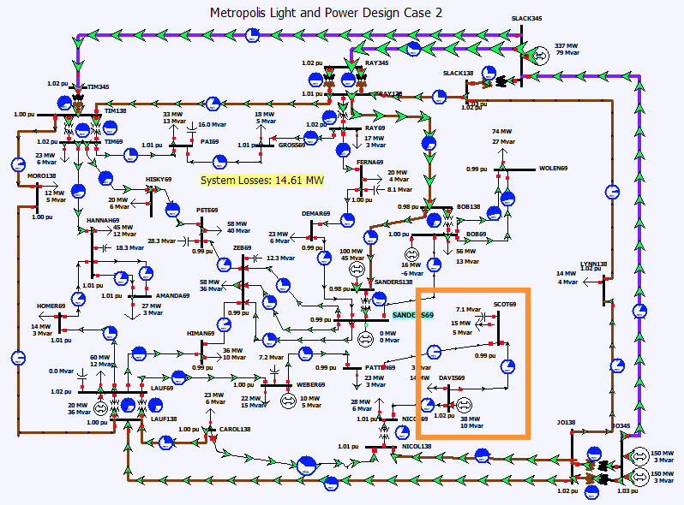

Figure 1: The overall schematic of the circuit is shown, where the transmission line from DAVIS69 to SCOT69 is highlighted.

**Calculations**

Data of the system will be needed to estimate the ABCD parameters, which is found in PowerWorld. From the branch of information seen below, the p.u. value of the total impedance and admittance of the transmission line is obtained. Z = 0.36163 + j1.2731 p.u. and Y = j0.0136 p.u

Vs = 1.02 < -19.05 p.u. and Vr= 0.99 < -27.37 p.u. Also, Is= 94.28 A and Ir = 93.3 A. Ps = 11.46 MW and Pr = 11 MW. It is important to notice that the receiving end power factor = ∅r = 1 because the reactive power is not being consumed.

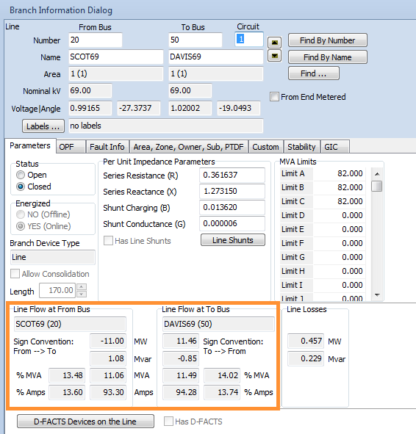

The actual values of the line impedances and admittances from the run mode cannot be found. In addition, the length of the transmission line cannot be seen. Therefore, the information will be gathered from the information dialog from the edit mode.

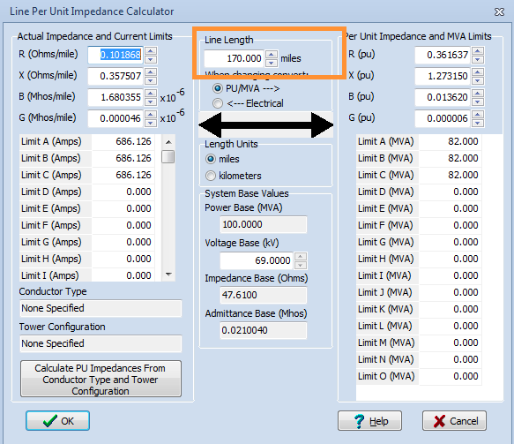

The length of the line as 170 miles, which is a long transmission line, is given by the following process. Hence, the long line model will only be used for this case and the results will be compared with the aforementioned PowerWorld data. Sbase = 100 MVA, kVbase = 69 kV and Zbase = 47.6

The base value for the current will be calculated with the information from the line per unit impedance calculator.

Ibase = = = 836.74 A

*Long Line Model*

Formulas needed to do the long transmission line model:

A = D = coshγl

B = Zc sinhγl

C = $\frac{1}{Zc}$ sinhγl

Vr = D*Vs – B*Is

Ir = - C*Vs + A*Is,

Zc =

γ = $\sqrt{(Z)*(Y)}$,

γl = $\sqrt{(Z)*(Y)}$ l

Vs = Vr coshγl + Zc Ir sinhγl

Is = Ir coshγl + $\frac{Vr}{Zc}$ sinhγl

cosh (x+jy) = cosh(x)cos(y)+jsinh(x)sin(y)

sinh(x+jy) = sinh(x)cos(y)+jcosh(x)sin(y)

Now, the Ir will be calculated with the PowerWorld values for Vs, Vr, and Z

γ = $\sqrt{( 0.36163 + j1.2731 )*(j0.0136)}$ = $0.018506+j0.132878$

Zc == = 9.77046 – j1.36076

A = D = coshγl = -9.62194 - j6.53186

B = Zc sinhγl = -102.585 – j51.0112

C = $\frac{1}{Zc}$ sinhγl = -0.870816 – j0.792292

Ir = - C*Vs + A*Is = - (-0.870816 – j0.792292) * ( 1.02 < -19.05) + (-9.62194 - j6.53186)* Is

Ir = 1.10336 + j0.473966 + (-9.62194 - j6.53186) * Is

Is = Ir coshγl + $\frac{Vr}{Zc}$ sinhγl = 1.10336 * coshγl + j0.473966 * coshγl + (-9.62194 - j6.53186) * Is * coshγl -1.1262 - j0.300223

Is - (-9.62194 - j6.53186) * Is * coshγl= -8.64679 – j12.0677

Is * (1- (-9.62194 - j6.53186) * coshγl) = -8.64679 – j12.0677

Is = 0.106627 – j0.027295 = 0.110065 < 14.3586

Ir = 1.10336 + j0.473966 + (-9.62194 - j6.53186) * (0.106627 – j0.027295) = -0.100886 + j 0.040124

Ir = 0.108572 < -21.6887

And we know that Ibase = 836.74 A, where I pu = $\frac{I actual}{I base}$

Therefore, Ir actual = 0.108572 *836.74 = 90.8465 A and Is actual = 0.110065 *836.74 = 92.0958 A.

In theory, it should give me an answer that is closer to the simulation, but in reality the transmission line is not isolated as in the calculation. As a result, every single time I run the calculation I will get a slightly different answer, which can be seen in the following images.

**Results:**

According to the PowerWorld simulation, Ir = 93.3 A and Is = 94.28 A. The results are similar to the PowerWorld results with an estimated error of (93.3– 90.8465)/93.3 = 2.62%

Thus, it was observed the ABCD parameters can be effectively calculated from the data obtained from the PowerWorld. The values given by PowerWorld by manual calculations were verified, and they got a diminutive value for the error.

**Discussion**

In this problem, the concept of long transmission line was introduced. It was shown that the actual models that PowerWorld uses are very gave results similar to the answers from the manual calculations. Therefore, it can be concluded that using the long transmission line model will give an accurate answer. In addition, an error between the simulation and the hand calculation can be produce when doing the medium line model. There are several lines connected with the selected transmission line. Therefore, the sending current “Is” may vary from the calculation performed when isolating the transmission line and doing hand calculations. In reality, I will never get the exact same value because the part selected for analyzing will always be influences by the whole system.